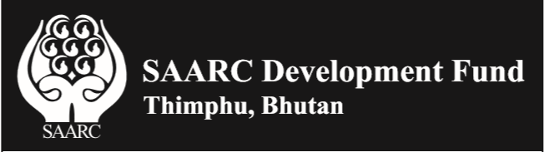

Call for Proposals for services of PR/Media and Communications for SDF in SAARC Member States
The SAARC Development Fund with its Secretariat in Thimphu, Bhutan, invites proposals from interested Public Relations Agencies/ Integrated Communication/Media Agencies for the services of developing PR/Media and communications strategy and related materials for SDF in SAARC Member States – Afghanistan, Bangladesh, Bhutan, India, Maldives, Nepal, Pakistan and Sri Lanka.

Interested bidders are requested to submit their Technical and Financial Bids under two separate
Password protected files by the close of business (before 1730 hours) on or before October 18, 2019 at ceo@sdfsec.org and admin@sdfsec.org

The Terms of Reference for above mentioned services are available on www.sdfsec.org.

Dr. Sunil Motiwal
Chief Executive Officer

